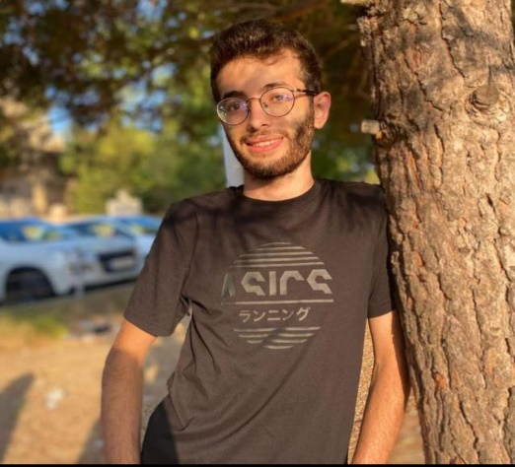

***In the academic year 2022-2023, I engaged in two transformative experiences that significantly contributed to my growth and expertise in the field of computer science:***

1. ***AI Project July 2023 – September 2023***

*Collaborating closely with my Supervisor, I played a vital role in an Artificial Intelligence (AI) project. Utilizing Node.js as a foundational reference, I actively contributed to the development of innovative solutions. This hands-on experience not only enhanced. my proficiency in Node.js but also provided me with a detailed understanding of the practical implementation of AI. Working under my Supervisor guidance, I perfected my problem-solving skills and gained valuable insights into the intersection of AI and software development.*

1. ***Frontend Development at XperBot August 2023- October 2023***

Concurrently, during the same academic year, I embraced a remote role as a Frontend Developer at Xperbot. In this dynamic position, I took charge of crafting engaging and responsive user interfaces, utilizing Vue.js to enhance the team's projects. Beyond honing my Vue.js skills, this experience provided me with exposure to effective remote collaboration, emphasizing communication and adaptability in a distributed work environment. As a Frontend Developer at Xperbot, I not only contributed to project success but also gained valuable insights into web development best practices.

***EDUCATION***

1. ***Bachelor of Art and Science in Computer Science***

**University Lebanese International University**

**Graduated:2023-2024 GPA:3.71**

1. **ENLGLISH - Fluent**
2. **ARABIC - Native**

***SUMMARY***

***EXPERIENCE***

***A Bachelor Degree holder of Computer Science, deeply passionate about programming. Proficient in languages like Java and Python, I thrive on solving complex problems and have a strong foundation in software development. My commitment is to stay up to date with emerging technologies, active involvement in coding communities, and love for continuous learning underscore. I am well-prepared to contribute to the evolving field of computer science.***

***HOBBIES:***

***SKILLS:***

***LANGUAGES:***

1. **FOOTBALL**
2. **CHESS**
3. **Programming Language:**
   * **Java**
   * **JavaScript**
   * **SQL**
4. **Web Development:**
   * **HTML**
   * **CSS**
   * **Node.js**
   * **PHP**
5. **Data Structures and Algorithms:**
   * **Understanding of various data structures (arrays, linked lists, trees, etc.)**
   * **Algorithm design and analysis**
6. **Soft Skills:**
   * **Problem-solving**
   * **Analytical thinking**
   * **Team collaboration**
   * **Communication skills**
   * **Time management**

**+961 76 020 867**

[**tarek.semhan2003@gmail.com**](mailto:tarek.semhan2003@gmail.com)

**Lebanon - Beirut**

***TAREK SAMHAN***